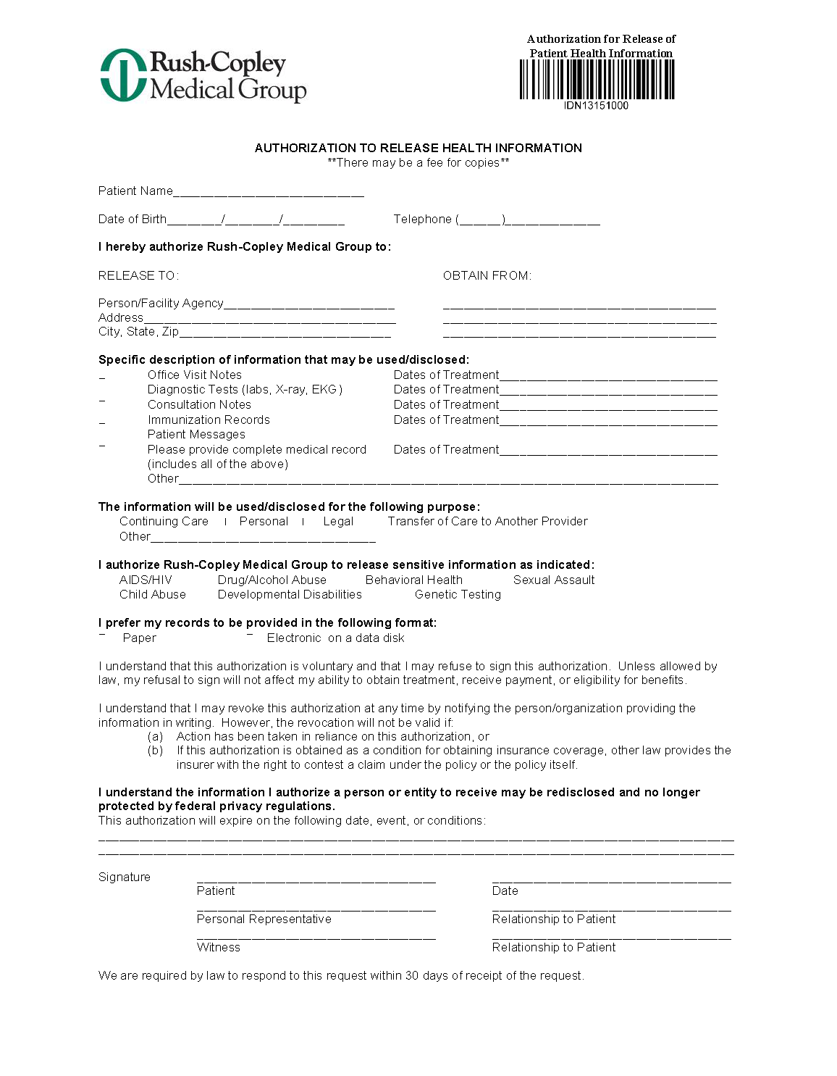
Batman
01/01/1979
Axiom Requisition Copy Service
2869 Jolly Road
Okemos, MI 48864
FROM 01/01/1979 TO PRESENT: Any and all MEDICAL RECORDS, including but not limited to patient history form(s), reports, etc. pertaining to Batman SSN: xxx-xx-5555, DOB: 01/01/1979.
✓

End of Litigation
✓

PH: (877) 886-5090 Fax: (517) 886-4116

